4. Python List

Python knows a number of compound data types, used to group together other values. The most versatile is the list, which can be written as a list of comma-separated values (items) between square brackets. Lists might contain items of different types, but usually the items all have the same type
The list is a most versatile datatype available in Python which can be written as a list of comma-separated values (items) between square brackets. Important thing about a list is that items in a list need not be of the same type.
Creating a list is as simple as putting different comma-separated values between square brackets. For example −
list1 = ['physics', 'chemistry', 1997, 2000];
list2 = [1, 2, 3, 4, 5];
list3 = ["a", "b", "c", "d"]

Accessing Values in Lists

list1 = ['physics', 'chemistry', 1997, 2000];
list2 = [1, 2, 3, 4, 5, 6, 7 ];
print "list1[0]: ", list1[0]
print "list2[1:5]: ", list2[1:5]
When the above code is executed, it produces the following result −
list1[0] => physics
list2[1:5] => [2, 3, 4, 5]

Updating Lists
You can update single or multiple elements of lists by giving the slice on the left-hand side of the assignment operator, and you can add to elements in a list with the append() method. For example −

list = ['physics', 'chemistry', 1997, 2000];
print "Value available at index 2 : "
print list[2]
list[2] = 2001;
print "New value available at index 2 : "
print list[2]
When the above code is executed, it produces the following result −
Value available at index 2 :
1997
New value available at index 2 :
2001

Delete List Elements
To remove a list element, you can use either the del statement if you know exactly which element(s) you are deleting or the remove() method if you do not know.

list1 = ['physics', 'chemistry', 1997, 2000];
print list1
del list1[2];
print "After deleting value at index 2 : "
print list1
When the above code is executed, it produces following result −
['physics', 'chemistry', 1997, 2000]
After deleting value at index 2 :
['physics', 'chemistry', 2000]

Basic List Operations
Lists respond to the + and * operators much like strings; they mean concatenation and repetition here too, except that the result is a new list, not a string.
In fact, lists respond to all of the general sequence operations we used on strings in the prior chapter.
Python Expression | Results | Description
len([1, 2, 3]) | 3 | Length
[1, 2, 3] + [4, 5, 6] | [1, 2, 3, 4, 5, 6] | Concatenation
['Hi!'] * 4 | ['Hi!', 'Hi!', 'Hi!', 'Hi!'] | Repetition
3 in [1, 2, 3] | True | Membership
for x in [1, 2, 3]: print x, | 1 2 3 | Iteration

Indexing, Slicing, and Matrixes
Because lists are sequences, indexing and slicing work the same way for lists as they do for strings.
Assuming following input −
L = ['spam', 'Spam', 'SPAM!']

Python Expression | Results | Description
L[2] | SPAM! | Offsets start at zero
L[-2] | Spam | Negative: count from the right
L[1:] | ['Spam', 'SPAM!'] | Slicing fetches sections

5. Repetition Structures

CONCEPT: A repetition structure causes a statement or set of statements to execute repeatedly.

# Get a salesperson's sales and commission rate.
sales = float(input('Enter the amount of sales: '))
comm_rate = float(input('Enter the commission rate: '))
# Calculate the commission.
commission = sales * comm_rate
# Display the commission.
print('The commission is $', format(commission, ',.2f', sep=''))
# Get another salesperson's sales and commission rate.
sales = float(input('Enter the amount of sales: '))
comm_rate = float(input('Enter the commission rate: '))
# Calculate the commission.
commission = sales * comm_rate
# Display the commission.
print('The commission is $', format(commission, ',.2f', sep=''))
# Get another salesperson's sales and commission rate.
sales = float(input('Enter the amount of sales: '))
comm_rate = float(input('Enter the commission rate: '))
# Calculate the commission.
commission = sales * comm_rate
# Display the commission.
print('The commission is $', format(commission, ',.2f', sep=''))

The while Loop: a Condition-Controlled Loop

CONCEPT: A condition-controlled loop causes a statement or set of statements to repeat as long as a condition is true. In Python you use the while statement to write a condition-controlled loop.

The while loop gets its name from the way it works: while a condition is true, do some task. The loop has two parts: (1) a condition that is tested for a true or false value, and (2) a statement or set of statements that is repeated as long as the condition is true. Figure 5-1 shows the logic of a while loop.

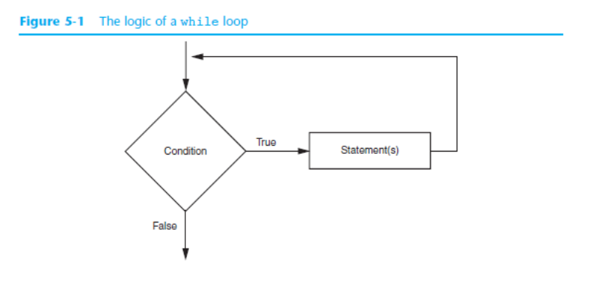

The diamond symbol represents the condition that is tested.
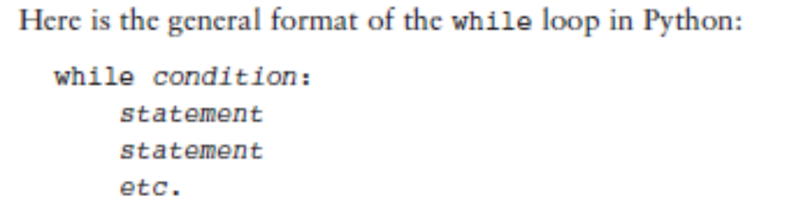

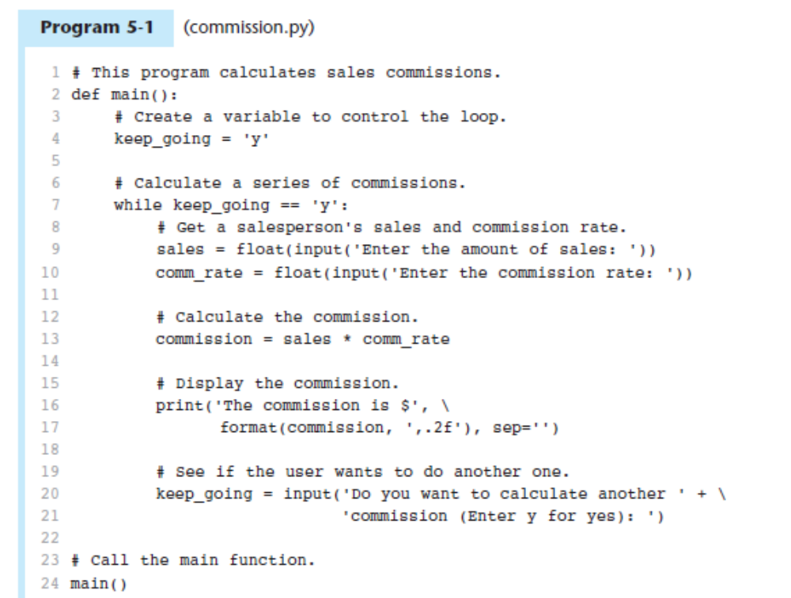

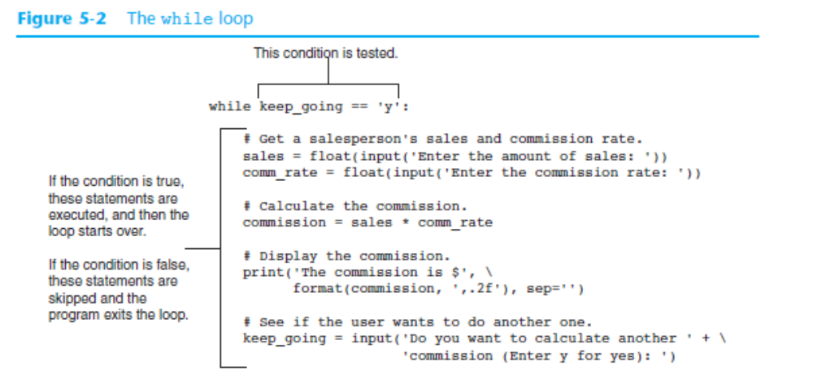

Infinite Loops
In all but rare cases, loops must contain within themselves a way to terminate. This means that something inside the loop must eventually make the test condition false. The loop in Program 5-1 stops when the expression keep_going == 'y' is false. If a loop does not have a way of stopping, it is called an infinite loop. An infinite loop continues to repeat until the program is interrupted. Infinite loops usually occur when the programmer forgets to write code inside the loop that makes the test condition false. In most circumstances you should avoid writing infinite loops.

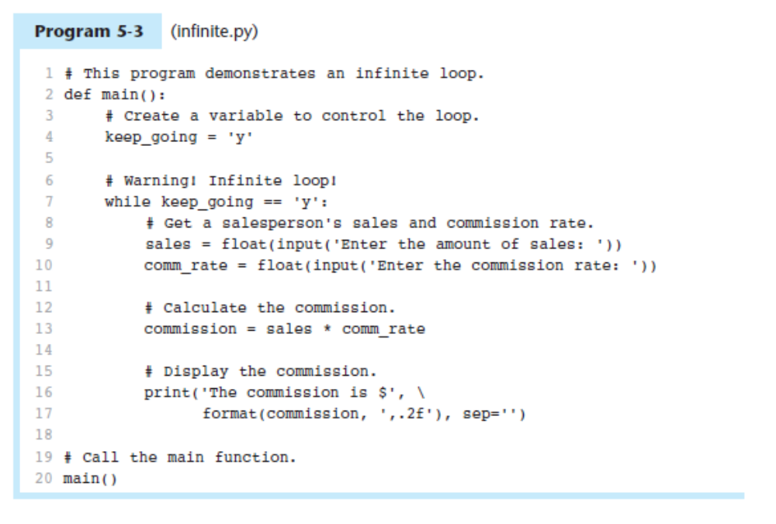
Calling Functions in a Loop
Functions can be called from statements in the body of a loop. In fact, such code in a loop often improves the design.

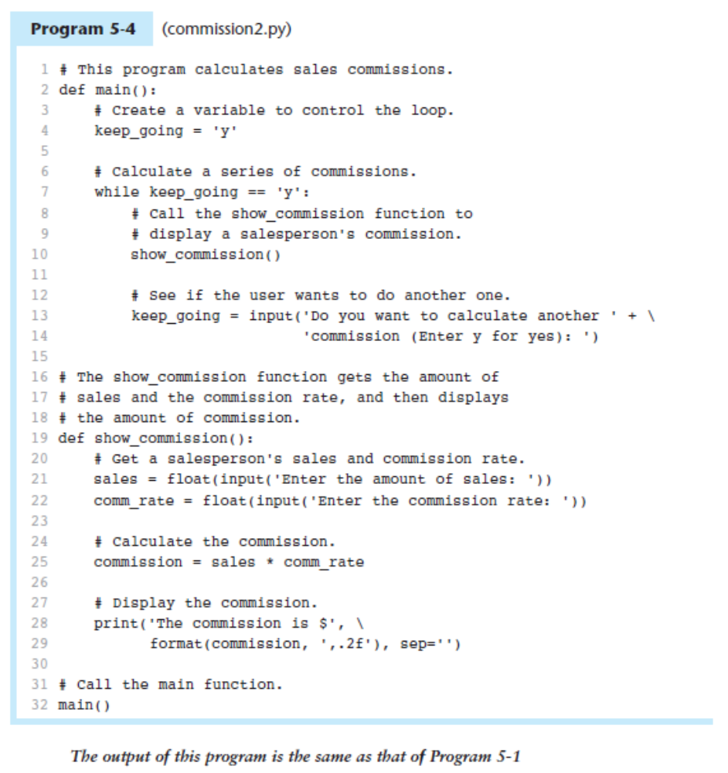

The for Loop: a Count-Controlled Loop

CONCEPT: A count-controlled loop iterates a specific number of times. In Python you use the for statement to write a count-controlled loop.
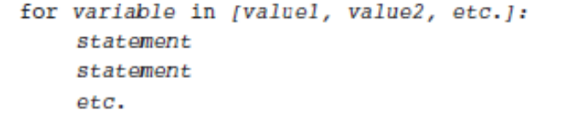

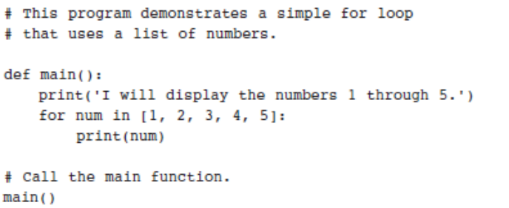

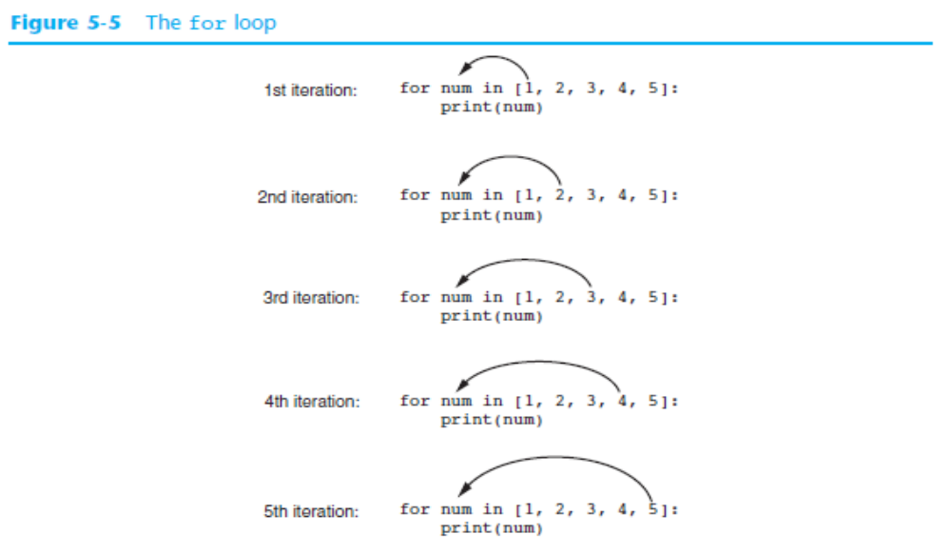

Using the range Function with the for Loop
Python provides a built-in function named range that simplifies the process of writing a count controlled for loop. The range function creates a type of object known as an iterable. An iterable
is an object which is similar to a list. It contains a sequence of values that can be iterated over with something like a loop. Here is an example of a for loop that uses the range function:

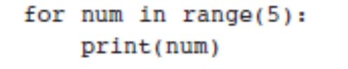

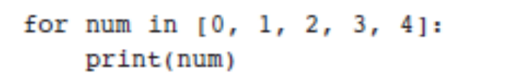

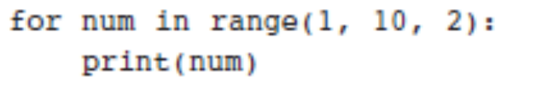

Letting the User Control the Loop Iterations

Sometimes the programmer needs to let the user control the number of times that a loop
iterates.

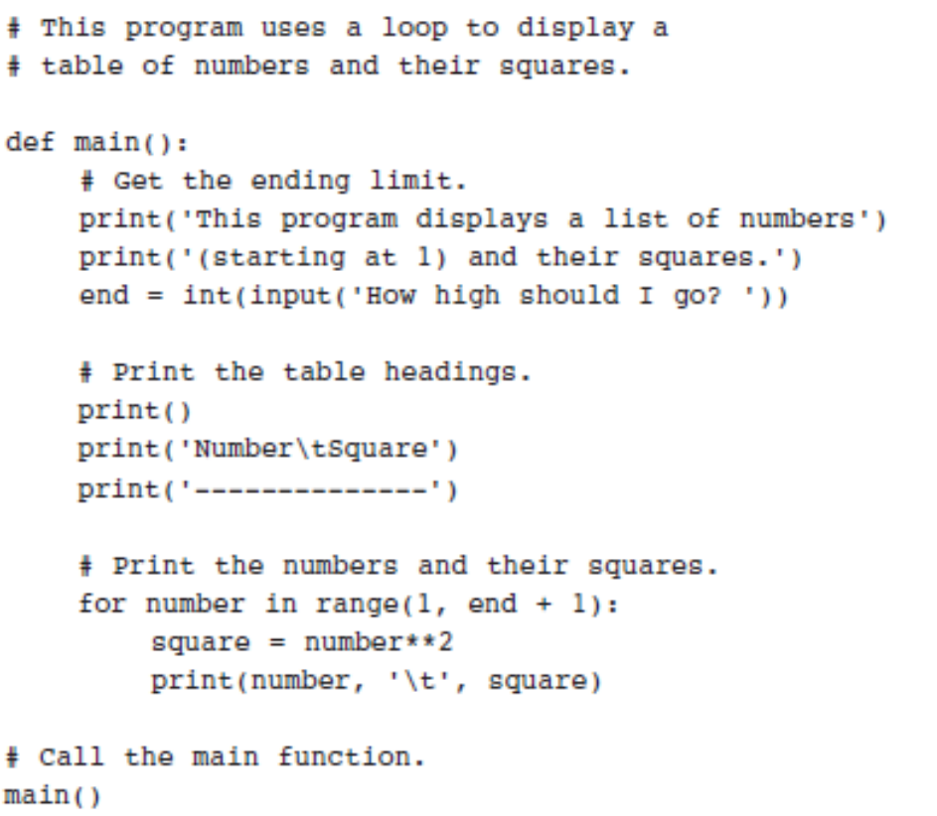

Calculating a Running Total
CONCEPT: A running total is a sum of numbers that accumulates with each iteration of a loop.

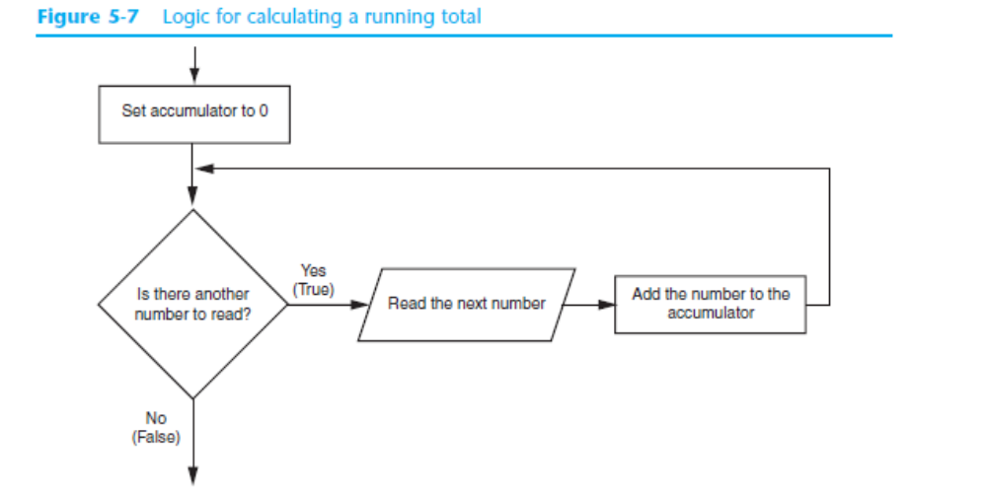

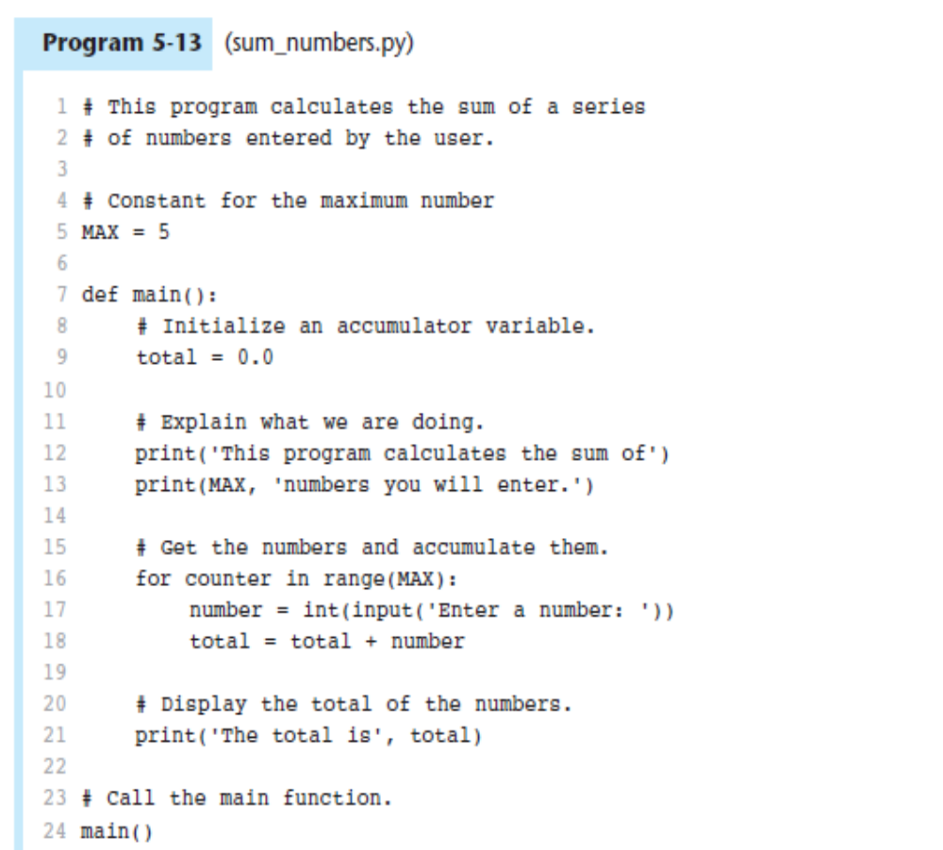

The Augmented Assignment Operators

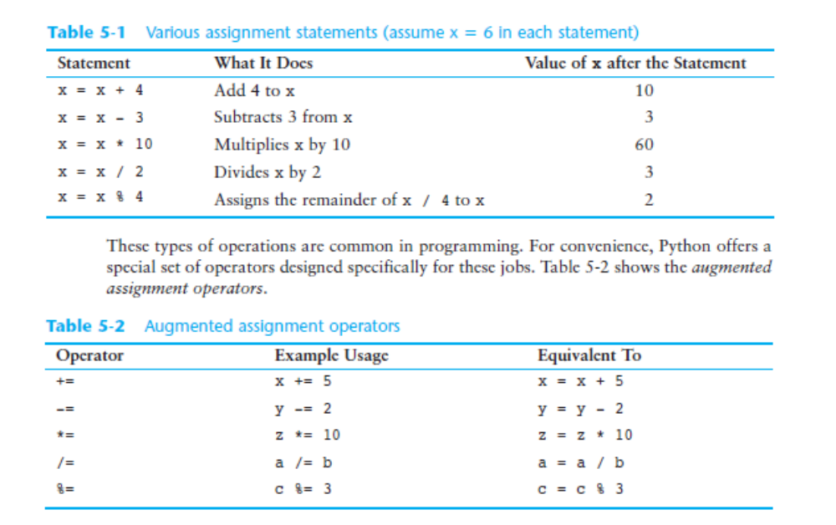

Nested Loops

CONCEPT: A loop that is inside another loop is called a nested loop.

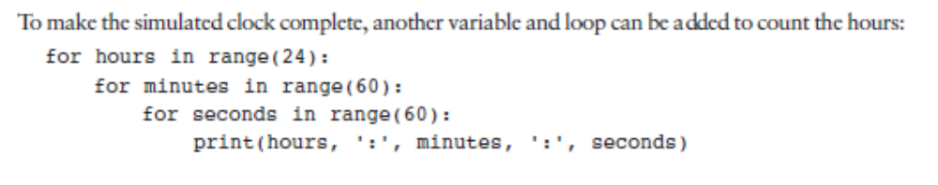

Exercices

